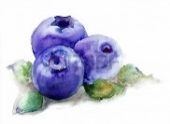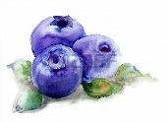　**Tohoku University Kawatabi Field Center – open course 2019**

Blueberry picking & jam making workshop

Application form

|  |  |  |  |  |  |
| --- | --- | --- | --- | --- | --- |
| ふりがな |  | | D.O.B | | Gender |
| Name |  | | yyyy/mm/dd | | M　・　F |
| ふりがな |  | | D.O.B | | Gender |
| Name |  | | yyyy/mm/dd | | M　・　F |
| ふりがな |  | | D.O.B | | Gender |
| Name: |  | | yyyy/mm/dd | | M　・　F |
| Adress: | 〒（　　　　　―　　　　　　　　） | | | | |
| Tel: |  | Emergency Contact: | |  | |
| Date of event | **Course 1- July 2** | | **Course 2- July 5** | | |
| ※Please use this space for any extra comments. | | | | | |

※ Personal information provided is to be used for this course only.

※ If you are intending on bringing small children, please add their names on the form.

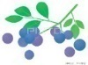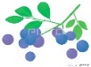

Enrolment process

Send your application form via fax or email

We look forward to seeing you at

Kawatabi Field Science Center !

Notification on your enrolment status will be sent from the center



**Deadline：June 14 (places go to the first 10 participants to enroll)**

**★　Contact　★**

Tohoku University Kawatabi Field Science Center

〒989-6711　Miyagi prefecture, Osaki City, Naruko Onsen, Yomogida 232-3

　TEL：0229-84-7312　　FAX：0229-84-6490

E-mail ： far-syom@grp.tohoku.ac.jp

HP： http://www.agri.tohoku.ac.jp/kawatabi/index.html

