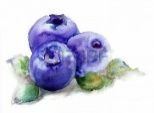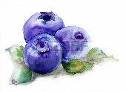　**Tohoku University Kawatabi Field Center – open course 2016**

Blueberry picking & jam making workshop

Application form

|  |  |  |  |  |  |
| --- | --- | --- | --- | --- | --- |
| ふりがな |  | | D.O.B | | Gender |
| Name |  | | yyyy/mm/dd | | M　・　F |
| ふりがな |  | | D.O.B | | Gender |
| Name |  | | yyyy/mm/dd | | M　・　F |
| ふりがな |  | | D.O.B | | Gender |
| Name: |  | | yyyy/mm/dd | | M　・　F |
| Adress: | 〒（　　　　　―　　　　　　　　） | | | | |
| Tel: |  | Emergency Contact: | |  | |
| Date of event | **Course 1- June 29 (Weds)** | | **Course 2- July 6 (Weds)** | | |
| ※Please use this space for any extra comments. | | | | | |

※ Personal information provided is to be used for this course only.

※ If you are intending on bringing small children, please add their names on the form.

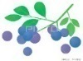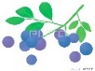

Enrolment process

We look forward to seeing you at

the Kawatabi Field Science Center !

Notification on your enrolment status will be sent from the center



Send your application form

by fax or email

**Deadline：June 22 (places go to the first 10 participants to enrol)**

**★　Contact　★**

Tohoku University Kawatabi Field Science Center

〒989-6711　Miyagi prefecture, Osaki City, Naruko Onsen, Yomogida 232-3

　TEL：0229-84-7312　　FAX：0229-84-6490

E-mail ： far-syom@grp.tohoku.ac.jp

HP： http://www.agri.tohoku.ac.jp/kawatabi/index.html

